Social Engineering, Phishing & Insider Threats

Objective
The objective of this lab is to understand Social Engineering attacks, their types, real-world impact, and hands-on exposure to phishing and social engineering tools used by attackers and ethical hackers. This lab focuses on awareness, attack simulation, and defensive understanding.

Module Overview
Social engineering is a manipulation technique that exploits human psychology rather than technical vulnerabilities. It remains one of the most effective cyberattack methods due to human trust, fear, curiosity, and urgency.
This module covers:
- Social Engineering fundamentals
- Types of Social Engineering attacks
- Phishing concepts and tools
- Insider threats and attacks
- Identity theft
- Practical lab tools and demonstrations

Key Concepts

Social Engineering
Social engineering is the art of tricking individuals into revealing confidential information or performing actions that compromise security.
Psychological Triggers Used:
- Trust
- Fear
- Greed
- Curiosity
- Urgency

Types of Social Engineering Attacks
- Phishing – Fake emails or websites to steal credentials
- Spear Phishing – Targeted phishing attacks
- Whaling – Attacks targeting executives
- Vishing – Voice-based phishing calls
- Smishing – SMS-based phishing
- Pretexting – Fake scenarios to gain trust
- Baiting – Free offers carrying malware
- Tailgating – Physical access exploitation
- Quid Pro Quo – Service exchange for information
- Dumpster Diving – Retrieving sensitive data from trash

Phishing Attack Lifecycle
- Research – Collect victim information
- Hook – Initiate deceptive communication
- Exploit – Steal data or credentials
- Exit – Cover tracks and disengage

Insider Threats
Insider threats arise from individuals with legitimate access.

Types of Insider Threats
- Malicious Insider – Intentional data theft
- Negligent Insider – Careless behavior
- Compromised Insider – Hijacked credentials
- Third-Party Insider – Vendor-related risks

Impacts
- Financial loss
- Data breaches
- Operational disruption
- Reputation damage

Identity Theft
Identity theft involves unauthorized use of personal information.

Common Types
- Financial identity theft
- Criminal identity theft
- Medical identity theft
- Tax identity theft
- Synthetic identity theft

Tools Used in Lab
⚠️ Disclaimer: All tools were used strictly in a controlled lab environment for educational purposes only.
- Koadic
- SocialPhish 2.0
- Pyphisher
- Zphisher
- SEtoolkit (Social Engineering Tool Kit)

1. Koadic
A post-exploitation framework similar to Metasploit.
Installation & Execution:
git clone https://github.com/offsecginger/koadic.git
cd koadic
python3 koadic
run
zombies
cmdshell <zombie_id>
kill <zombie_id>
📸 Screenshot : Koadic dashboard and zombie connection


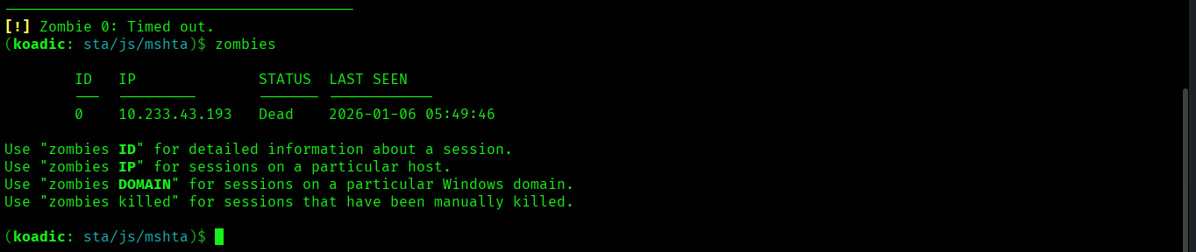

2. SocialPhish 2.0
A phishing framework with pre-built templates.
Installation:
git clone https://github.com/BDhackers009/SocialPhish-2.0.git
cd SocialPhish-2.0
📸 Screenshot: Tool interface and phishing template selection
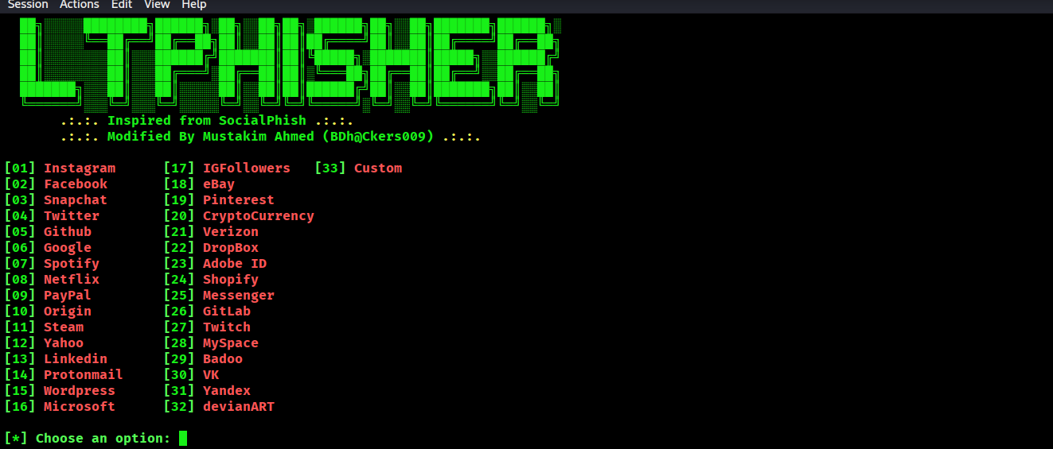

3. PyPhisher
An advanced phishing automation tool.
Installation & Execution:
git clone https://github.com/KasRoudra2/PyPhisher
cd PyPhisher
pip3 install -r requirements.txt
python3 pyphisher.py
📸 Screenshot: Phishing link generation
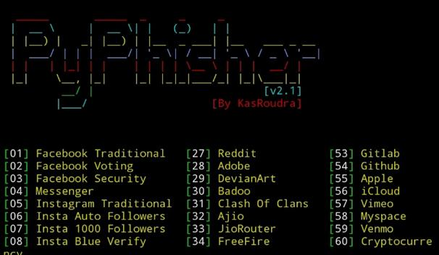

4. Zphisher
Zphisher is a popular automated phishing framework used for awareness testing and educational demonstrations. It provides multiple pre-built phishing templates for popular platforms and supports tunnel services for link sharing.
Installation & Execution:
git clone https://github.com/htr-tech/zphisher.git
cd zphisher
bash zphisher.sh
Key Features:
- Pre-built phishing templates (Instagram, Facebook, Gmail, etc.)
- URL masking and tunneling support
- Credential capture for awareness simulation
📸 Screenshot: Zphisher main menu and generated phishing link
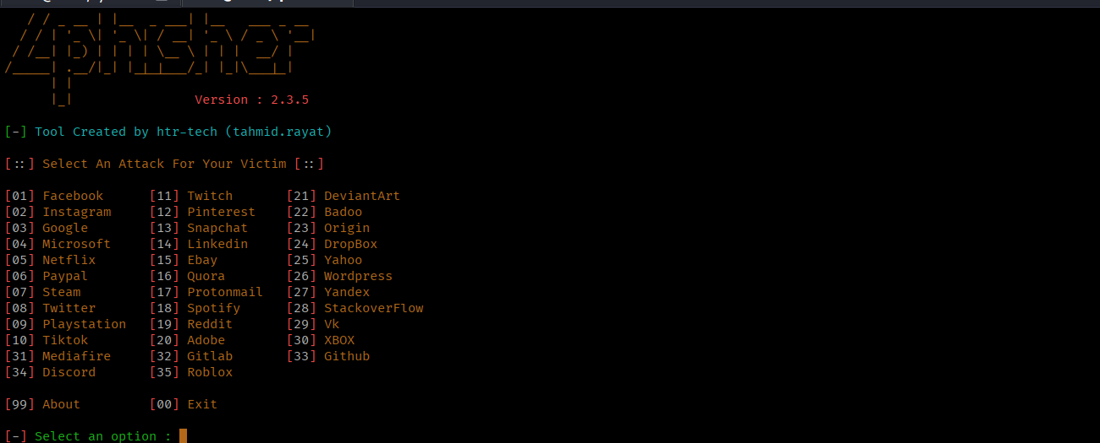

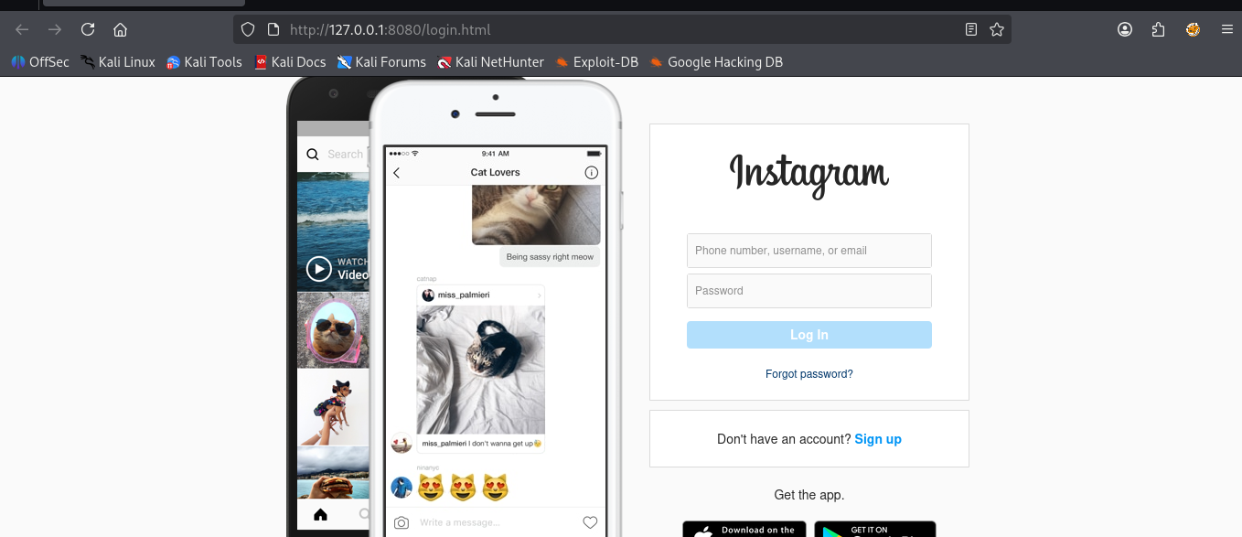

5. SEToolkit (SET)
A social engineering penetration testing framework.
📸 Screenshot: SEToolkit phishing attack setup
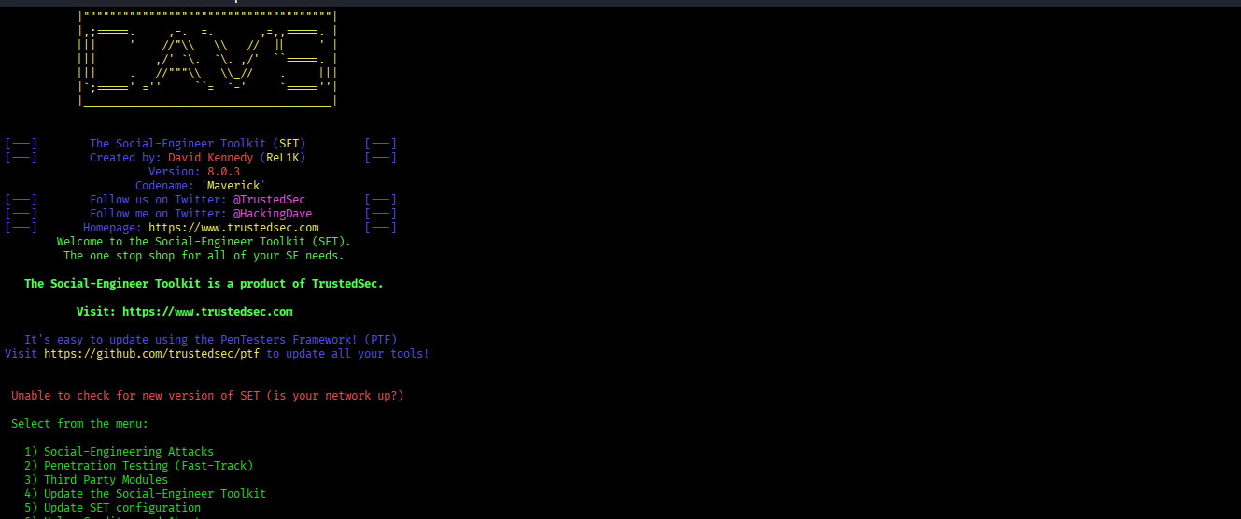

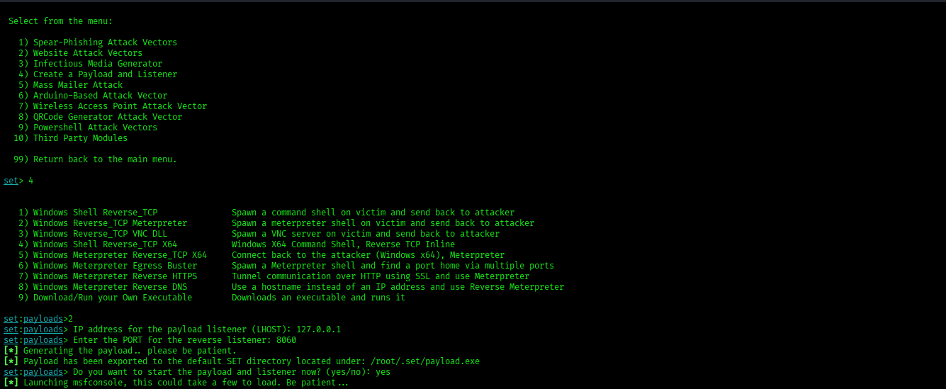

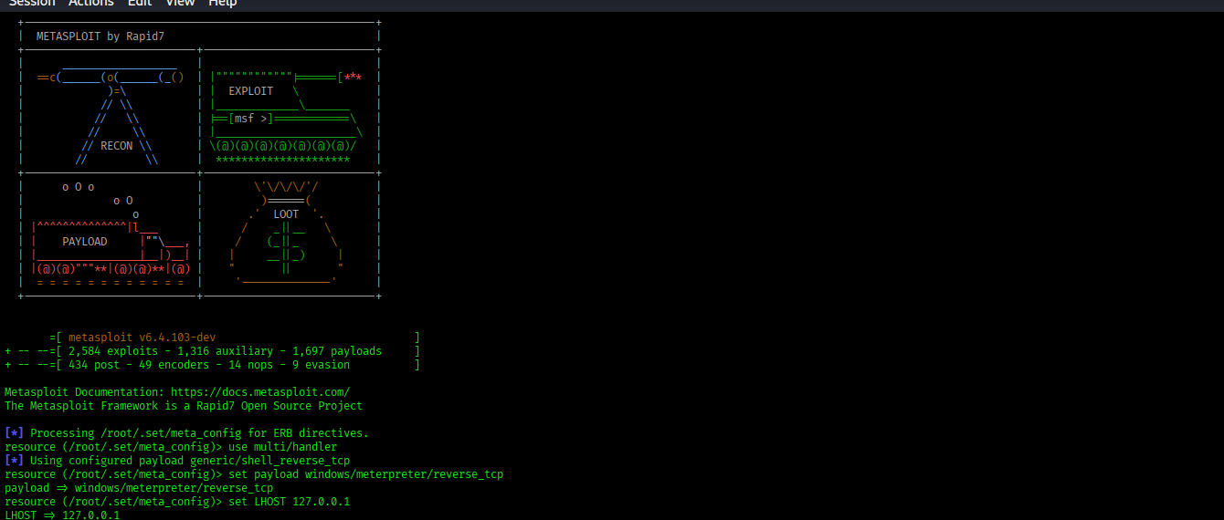

Defensive Measures

Prevention Strategies
- Security awareness training
- Multi-Factor Authentication (MFA)
- Email filtering & spam protection
- Verification of requests
- Role-based access control (RBAC)

Learning Outcomes
- Understood human-based cyberattacks
- Gained hands-on experience with phishing tools
- Learned ethical usage of attack simulation tools
- Improved awareness of insider threats
- Developed practical cybersecurity reporting skills

Author
Name: Kiran Karenavar
Course: Cybersecurity / Ethical Hacking
Module: Social Engineering | Ethical Hacking Lab Project

Conclusion
Social engineering remains one of the most dangerous cybersecurity threats due to its focus on human behavior rather than technical flaws. Through this lab, I gained both theoretical understanding and practical exposure to phishing and social engineering techniques, reinforcing the importance of cybersecurity awareness and ethical hacking practices.

